herzlich willkommen zum erklärungsvideo des citeeecar-projektes. Hier erklären wir in 5 minuten: was das besondere am citeeecar ist, wofür es gut ist, und wie es hergestellt wird.
das citeeecar ist ein dreisitziges elektroauto,

welcome to the explanatory video of the citeeecar project. Here we explain in 5 minutes: what is special about the citeeecar, what it is good for and how it is made.
the citeeecar is a three-seater electric car,

das ohne lenkrad und pedale auskommt. Stattdessen wird es mittels joysticks gesteuert, der auch mechanisch die hydraulischen Scheibenbremsen kontrolliert.

without a steering wheel and pedals. Instead, it is controlled using joysticks, which also mechanically control the hydraulic disc brakes.

this is the minimum quality i demand as example: https://www.youtube.com/watch?v=nVo0GuNm3Ek&t=7s
What is it?
2m-10sec
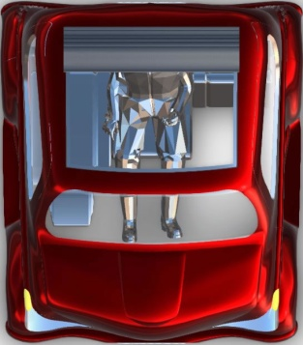
Turn car 360° all axes
3 seats
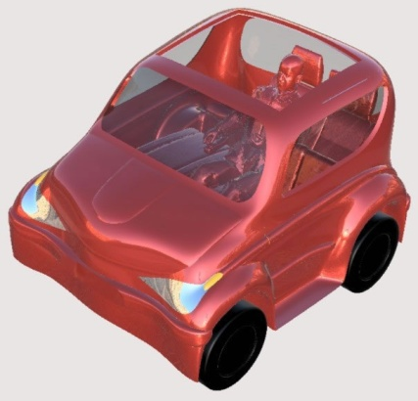
No steering wheel=joystick 10 sec
Zoom in on interior from above
No pedals =joystick

5 sec
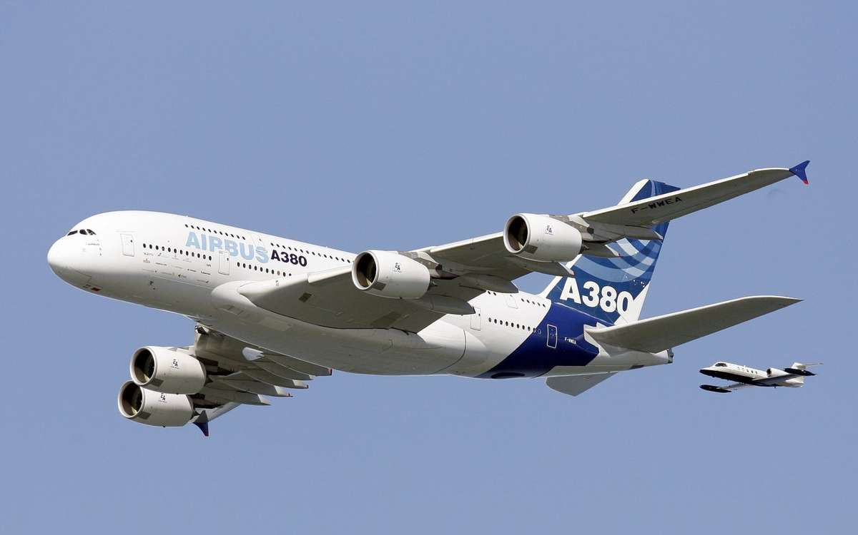
Zoom into cockpit
Joysticks steuern heutzutage die grössten Flugzeuge,

Nowadays joysticks control the largest aircraft

aber auch schon besondere Autos.

but also special cars.

Das citeeecar ist unglaublich vielfältig nutzbar: die heckklappe ermöglicht das einschieben von drei flightcases unter die sitze.

The citeeecar is incredibly versatile: the tailgate allows three flight cases to be pushed under the seats.

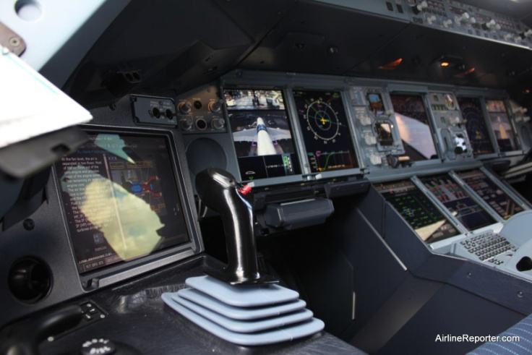

https://vimeo.com/97300120
sec 2:48-2:52 =5 sec
write “source: paravan.com” below

Lids and loads 11 sec
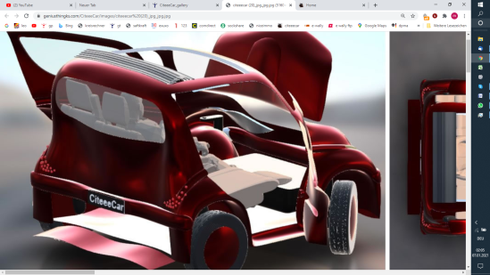
Push in 3 flightcases, during zooming to rear
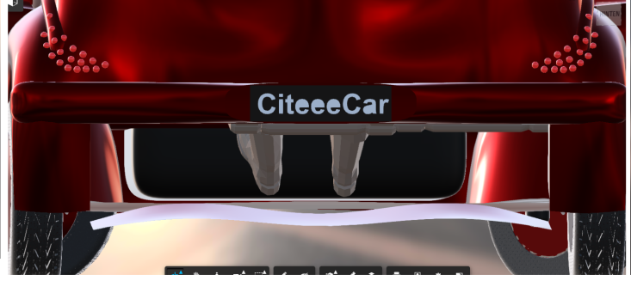

Und bietet platz für einen grossen vollen einkaufswagen im vorderen bereich

And offers space for a large, full shopping cart in the front area

Das liegt daran, dass die radnabenmotoren keinen innenraum einnehmen.

This is because the wheel hub motors do not take up any interior space.
Push in a trolley and Load grocery stuff in the car s front
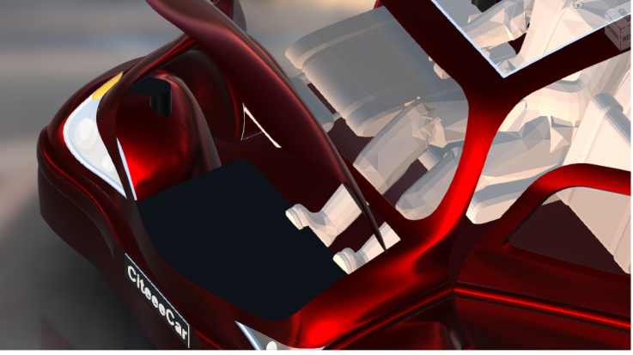

Hub motor 11 sec
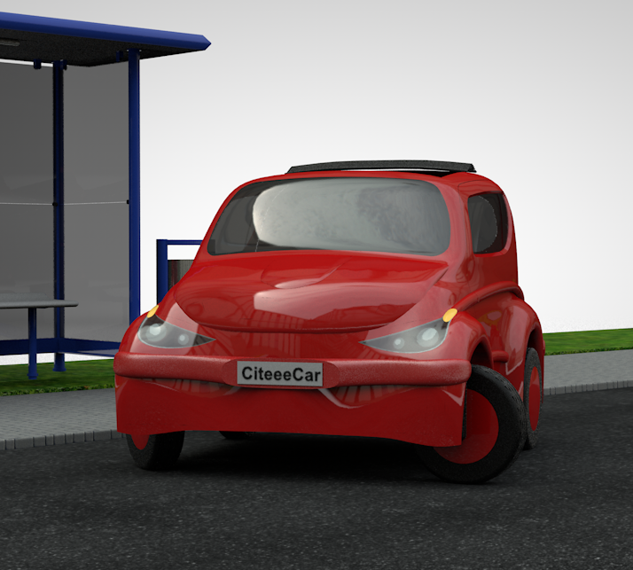
Zoom to wheel
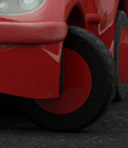
Show disc brakes and hub motor (design both)
Das citeeecar wird durch zwei radnabenmotoren angetrieben. Dies ermöglicht eine drehmomentverteilung und optimale anpassung an die fahrbahn

The citeeecar is powered by two wheel hub motors. This enables torque distribution and optimal adaptation to the road surface

Die individuelle spurstangenlose radlenkung erlaubt ein

The individual wheel steering without tie rods allows a

koordiniertes drehen um das zentrum jedes hinterrads, sodass

coordinated turning around the center of each rear wheel so that

Das citeeecar das einzige dreisitzige strassenzugelassene Auto kleiner als 2m ist, das ohne rechtliche bedenken perpendikular in eine parklücke passt,

Und dabei noch nicht einmal den gegenverkehr stört.

The citeeecar is the only three-seater street-legal car smaller than 2m that fits perpendicularly into a parking space without any legal concerns,

And don't even bother oncoming traffic.

torque vectoring
https://www.youtube.com/watch?v=d1UG1a38diw
see sec 5-7=3 sec and do something similar, but no central motor, no axis (shafts), and in the front
8 sec:
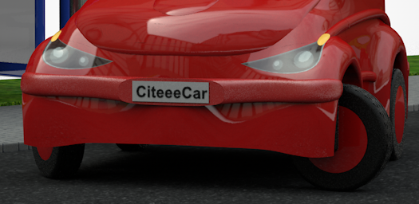
Turn wheels independently

Turn on rear wheel
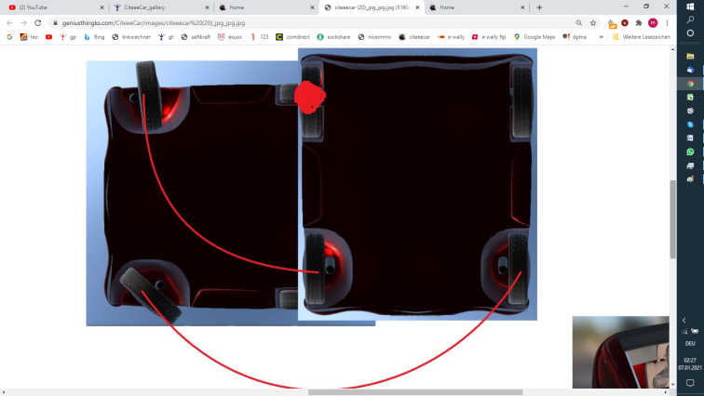

Legally Perpendicular parking 13 sec
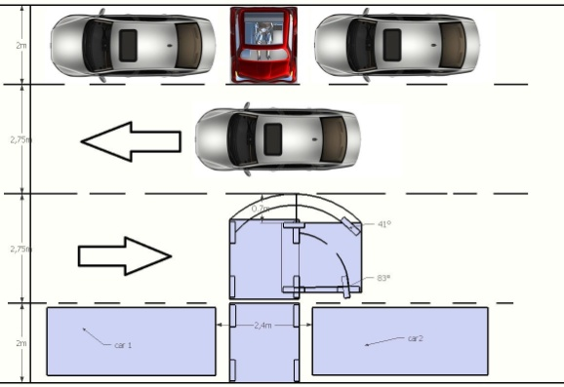
Show car parking from above, then from street view rear and front

Die Rückleuchten sind im ausgeschalteten zustand kaum zu erkennen, und natürlich bietet das citeeecar tageslicht-LEDs hinten

The taillights can hardly be seen when switched off, and of course the citeeecar has daylight LEDs at the rear

Wie auch vorne

As in the front

Für ein besonderes vergnügen sorgt eine elektrisch aufblasbare riesige matratze im queen size format, die auf die umklappbaren rücklehnen gelegt wird und innerhalb von 2 minuten einsatzfähig ist.

A huge, electrically inflatable mattress in queen size format, which is placed on the foldable backrests and is ready for use within 2 minutes, provides a special treat.

Wofür ist das citeeecar nun gut?
Zunächst einmal natürlich für die familie als preiswerter umweltfreundlicher zweitwagen

What is the citeeecar good for?
First of all, of course, for the family as an inexpensive, environmentally friendly second car

Lights, click on light on, break, reverse, blinker, drl, etc 7 sec
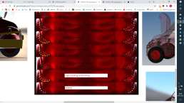
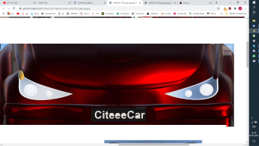
Drl=daylight running lights 2 sec

Inflatable Bed, push down 3 seat backs, unfold a box with size of one seat (ie 40x40x20cm) 4 times to cover the whole space and pump up air mattress, 15 sec
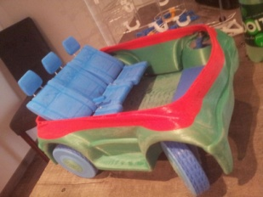
Lay 2 people ontop of bed and put car on hill, dim down to night, show stars from bed perspective through open roof and let a heart fly out of roof

What is it good for? 8 sec

What about digital billboards with wifi and dc-fastcharge capacities, paid by the advertiser – the daily business of ie JCDecaux- installed near parking strips for charging two cars in ca 15-30 minutes.

or imagine those chargers on parking lots of supermarkets, hardware stores, etc. Interactions like drive to store or even better buy at store by placing a cheap scanner in the billboard unit, letting the client scan the receipt to get a kWh for free, would be an easy to implement and fruitful affair. The number of free kWh depends on the total sale and/or special offers, whatever the store configured and sent to the billboard server, maybe the first time an outdoor-advertising-company could be paid by real sales?! Values per sales slip are valid for a certain time at all chargers using the same server network worldwide, and receipts are cumulatable, aggregatable, transferable and usable in flexible portions.

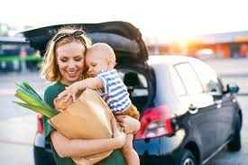
Show mother with 2 children shopping and stepping in car, so mother and 2 kids
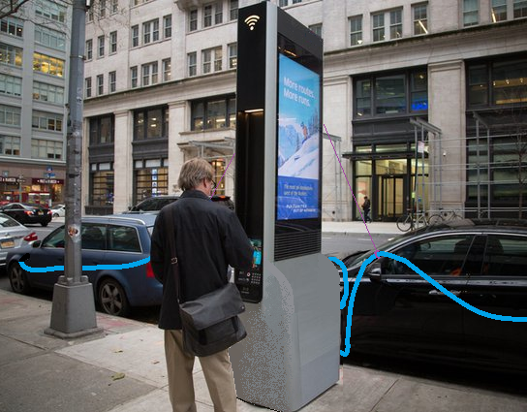
Zoom down on our town to a parking strip and show the billboard charging 2 cars.

Show a parking lot with the billboard charging 1 car, mom arrives with cart (scene from before), take a perfume box, scans it at billboard, and screen shows “thank you for buying this wonderful perfume. As a gift you can now charge 3kWh for free!” Show mom jumping up, rising arms, winner pose.
Das citeeecar eignet sich aber auch hervorragend für den autonomen taxiservice. Schliesslich werden wir immer älter und wollen unseren bewegungsradius auch im fahruntüchtigen alter nicht eingeschränken. Der weg zur nächsten station kann aber schon zu weit sein. da käme das citeeecar gerade richtig!

The citeeecar is also ideally suited for the autonomous taxi service. After all, we are getting older and older and do not want to restrict our range of motion, even when we are not able to drive. But the way to the next station can be too far. the citeeecar would be just right!

Stellen sie sich kommunalen bustransport der nahen zukunft vor: anstatt der riesentransporter, die nur von busstation zu busstation fahren können, werden bald die kleinen einheiten eingesetzt, die nun individuell bis vor die haustür kommen. So können wir unsere freunde auch noch im hohen alter besuchen!

Imagine municipal bus transport in the near future: instead of the giant vans that can only travel from bus station to bus station, the small units will soon be used that will now come individually to the front door. So we can still visit our friends in old age!

Wie wird das citeeecar hergestellt?
Die produktionsweise des citeeecars ist eine ganz besondere.

How is the citeeecar made?
The production method of the citeeecar is very special.

Stellen sie sich einen würfel vor, den sie in zwei hälften teilen

Imagine a cube that you split in half
- Private second car for short trips
- Self driving taxi
- Ddpt=door to door public transport 13 sec
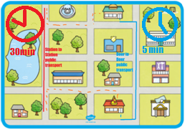
Take houses or a whole environment from ie grabcad and show how someone walks to station A, bus driving to station B, then walking and to other house and show clock on left side, and then blue line citeeecar goes and show clock on right side.
Show bus with people inside like shown, cut bus into sections and morph each section to one car, 8 sec
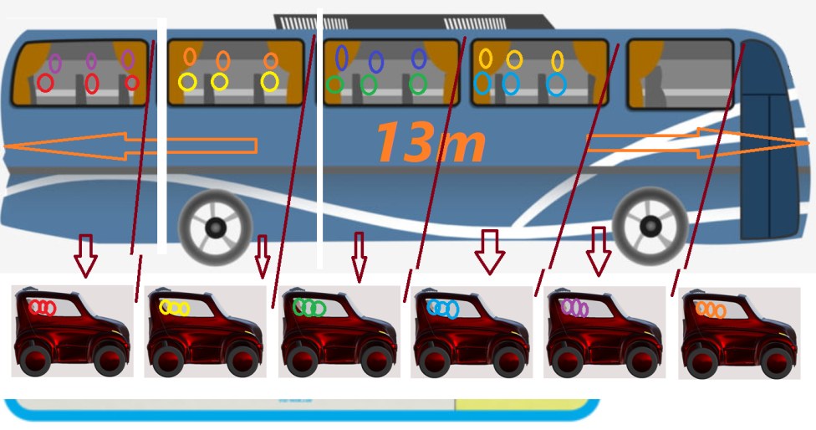

How is it produced?
2 inner, 2 outer foils, Dice with 3 sides each, 18 sec
Show the dice, then cut as shown

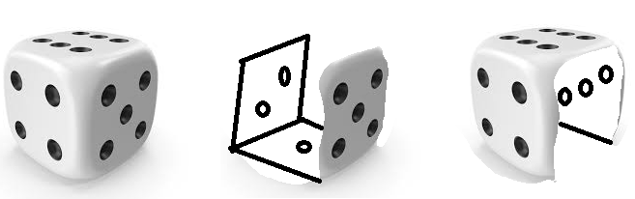

Delete dice dots and cut in windows etc
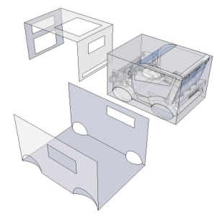
Blend in the car inside the dice-cube,
Cut the foil in the bonnet section a bit and lay/wrap the foil onto the car s body

Bend the upside foils down to the ground
Anders als herkömmliche pkw, die ihre steifigkeit durch punktgeschweisste ausgestanzte dünne blechfolien erhalten, besteht das citeeecar aus einem ca 5cm dicken sandwich aus einem geschweissten aluminiumrohrrahmen in ihn verkleidenden je 3mm starken abs folien. Diese folien werden in einem einzigen arbeitsschritt in ihre form gebracht, wie das geht das sehen wir gleich.

In contrast to conventional cars, which get their rigidity from point-welded, punched-out thin sheet metal foils, the citeeecar consists of an approx. 5 cm thick sandwich made of a welded aluminum tubular space frame, which is clad in 3 mm thick ABS foils. These foils are shaped in a single work step, we will see how this works in a moment.

Die rohrbiegemaschine formt den sicherheitskäfig aus möglichst wenigen stücken, damit nicht so viel geschweisst werden muss.

The pipe bending machine forms the tubular safety cage space frame from as few tubes as possible so that not so much has to be welded.

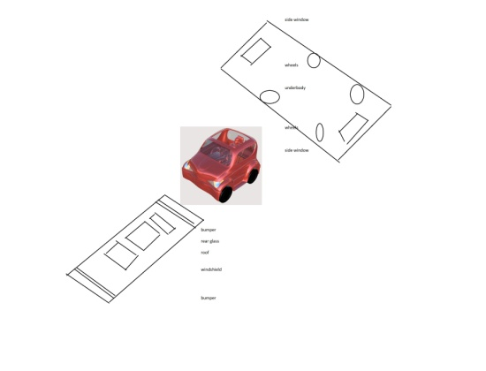
Freeform tube bender Sec 3-10=8 sec
Cut away text in film like shown here
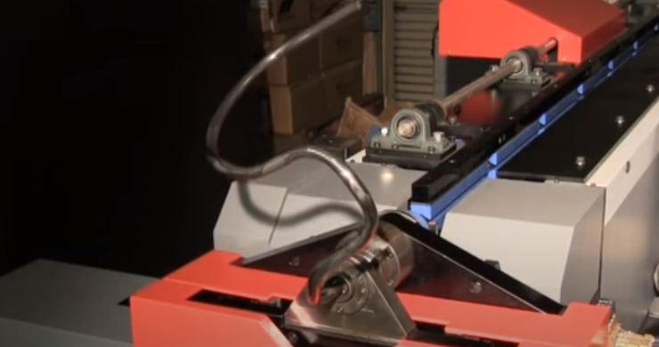

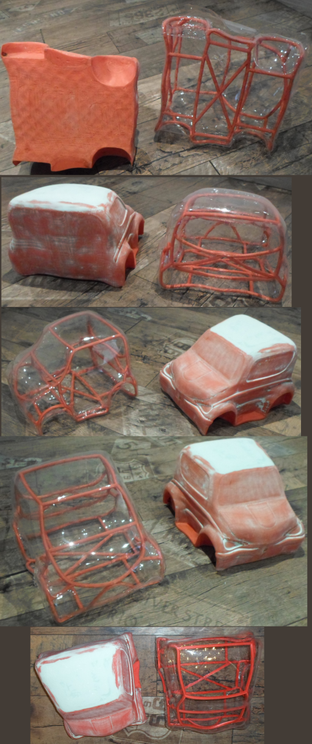
Das sandwich aus rohrkäfig und dicken kunststoffplatten bildet die ca 5cm dicken wände des citeeecar.

The sandwich made of a pipe cage and thick plastic plates forms the approx. 5cm thick walls of the citeeecar.
Sandwich= plastic foils & alutube in between 11 sec
Show how machine create 2 cages: one for upper section, one for lower car section.
show how
take the wrapped foils you did above and lay lower section foil on ground, put lower cage in,
show upper foil laid upside down onto ground, put cage in, turn upper section 180° and put one onto the other , put wheels/suspension on

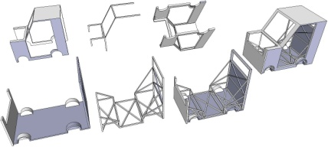

Ein ganz tolles feature des citeeecar ist die ganz individuelle bedruckung. Wir möchten, dass kein citeeecar jemals mehr dem anderen gleicht, und sie bestimmen zu hause am computer das design

A really great feature of the citeeecar is the very individual paint job. We want no citeeecar to be ever the same again, and you determine the design on your computer at home

Dabei können sie sich natürlich von vorlagen inspirieren lassen

You can of course be inspired by templates

Freeform painting 25 sec
Car print online configurator
Lay the 2 foils of above section onto ground,
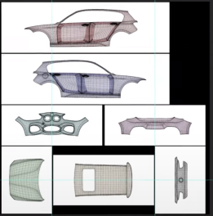
Show “themes” on internet like for webpage design, like ie flowers or colored cubes or planes or teddy bears, or a mountain (your tengri), or the sun. or desert, or snow, or police/post/fire/etc symbols with their own colors.
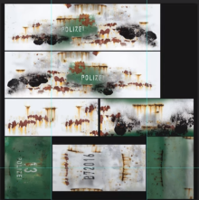
Show how click on one theme and show what the car in that theme would look like, and that everything can be modified (pull flower to make larger/smaller, change color, write personal text)
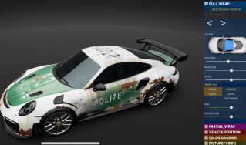
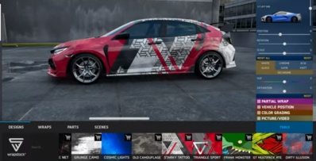
Show 10 different styles 0.3 sec each

Citeeecar print: 10 sec
Anders als beim herkömmlichen pkw bau, bei dem die lackierung nach dem zusammenbau vorgenommen wird, sind die aussen und innenseiten des citeeecar bereits bedruckt, bevor mit der produkterstellung überhaupt begonnen wird.

In contrast to conventional car construction, in which painting is carried out after assembly, the outside and inside of the citeeecar are already printed before the production of the product even begins.

diese drucker werden längst für planenbeschichtungen genutzt,

these printers have long been used for tarpaulin coatings,

unsere drucken eben die 3mm starken platten

ours just print the 3mm thick panels

Und nun ist alles möglich, vielleicht sogar wechselbare gehäuse, wie man es von handy abdeckungen kennt, wir arbeiten daran.

And now everything is possible, maybe even exchangeable housings, as we know it from cell phone covers, we are working on it.
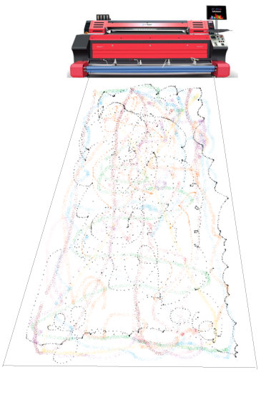
Show the printer and how a foil is printed in car design and car dims

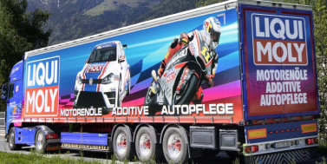
Show this pic to prove the print size exists already
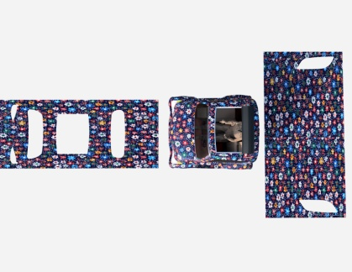
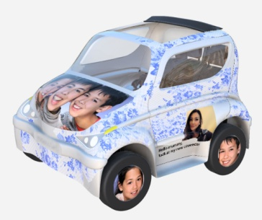
Show examples, like post car, police car, picture-car like above, ie 5x3 cars (3 lines of 5 cars next to each other), like standing on stock.
Unser patent des flüssigen heissen thermoformens erlaubt die aussergewöhnliche produktionsmethode:
Die bedruckte folien wird vom stapel gezogen und in ein heisses bad gelegt bis sie formbar ist.
Die urform drückt die folie nun in form, und das heisse öl saugt von innen bis der abdruck perfekt anliegt.
Dann härtet die folie im kalten wasser eines weiteren beckens.
Jeder zyklus benötigt lediglich 2 minuten, wir sparen die schweissroboterstrassen und die viele energie, die die herkömmlichen produktionsphasen benötigen.
Auch umwelttechnisch ist unser verfahren allen anderen weit voraus, bspw. durch die extrem günstige produktion, da keine lackiererei mit enormem wasserverbrauch benötigt wird.

Our patent of hot liquid thermoforming allows the extraordinary production method:
The printed film is pulled from the stack and placed in a hot bath until it is malleable.
The original shape now presses the film into shape, and the hot oil sucks in from the inside until the impression is perfectly attached.
Then the film hardens in the cold water of another basin.
Each cycle only takes 2 minutes, we save the welding robot lines and the large amount of energy that the conventional production phases require.
Our process is also far ahead of all others in terms of environmental technology, for example due to the extremely inexpensive production, as no paint shop with enormous water consumption is required.

Hier wird eine produktionslinie mit je zwei inneren und äusseren folien sowie der käfigherstellung gezeigt. Eine parallele kaskade kann leicht eine million autos pro werk auf so kleinem raum herstellen, wie noch niemals zuvor massenproduziert wurde.

Here a production line with two inner and two outer foils as well as the cage production is shown. A parallel cascade can easily produce a million cars per plant in such a small space as has never been mass-produced before.

Thermoforming patent, 30 sec
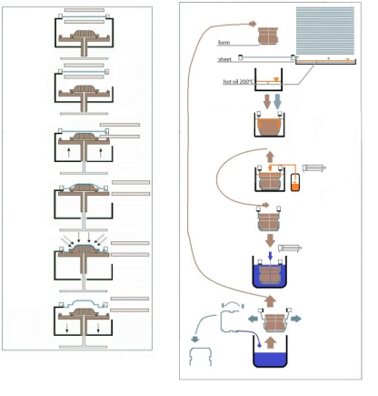
animate this patent-pending foil forming process:
turn citeeecar foil incl all windows and lids as one surface= one body upside down as mould part.
The clamps holding the foil need to turn and move, so the hot flat sheet is bent, NOT stretched. The oil level inside the basin moves to the upper mould surface when the mould nearly touches the basin ground.
Move the clamps onto the mould and start sucking the inside so that the sheet is sucked onto the mould body.
Keep sucking the inside while pulling the mould out of the basin and into the cold water basin.
Pull out of basin and stop sucking and let flow out oil and put form on ground.
Show same operation with other mould (top and bottom moulds).
Then show 2 other moulds (being the same form distance), so 4 in a row.
Now blend over to an industry production complex.
30 sec:
Fabrication, show flow and time (clock for total cycle 2min in fast motion)
show 4 chambers=4 moulds=4 foils (inner/outer dice)
inside foils are just a bit tinier as outside ones.
Divide cage production into two cages: one for top, one for bottom form, show how the ie 10m long “sausage” is pressed out of the bender.
Show how the interior is installed before the “marriage”. So install seats and battery package.
Then put the 2 parts together and put suspension and wheels on.
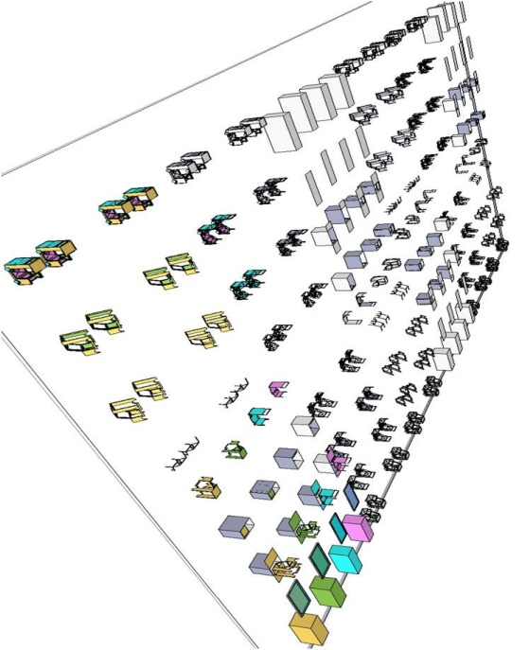
Zoom out to show multiple lanes and an output of 500 cars/day/lane=100000cars/lane/year, 10 lanes=1mio cars/year, 30m width per lane, 50m long, so 10 lanes=300m x 50m
Homologation-Analysis:

1. Geometric Parameters
- Wheelbase: 1.35 m
- Track width: 1.80 m
- Vehicle length: 2.00 m
- Longitudinal centre of gravity: centered at 1.00 m
- Assumed centre-of-gravity height for evaluation: 0.50 m
- Front axle: independent steering actuators
- Longitudinal stabilisation: electrohydraulic damping
- Vehicle category: L7e-B2

2. Static Rollover Threshold
The static rollover threshold is determined by the ratio between half the track width and the centre-of-gravity height.
With a half track width of 0.90 m and an assumed centre-of-gravity height of 0.50 m, the resulting static rollover angle is approximately 61 degrees.
This value is significantly higher than typical for L7e-class vehicles (approximately 35–45 degrees). The lateral stability margin is therefore exceptionally high.

3. Critical Lateral Acceleration
The critical lateral acceleration is governed by the same geometric ratio (half track width to centre-of-gravity height), scaled by gravitational acceleration.
For the present parameters, the theoretical limit is roughly 1.8 g.
Since tyre friction limits are typically much lower (around 0.9–1.1 g), tyre saturation will occur long before any rollover tendency. The vehicle is therefore laterally stable by geometry, independent of electronic control systems.

4. Longitudinal Stability
Despite the short wheelbase of 1.35 m, longitudinal stability remains adequate due to:
- centered longitudinal centre of gravity,
- wide track width, which suppresses pitch-induced yaw coupling,
- electrohydraulic pitch-damping, reducing front-rear load transfer.
The resulting behaviour approaches that of compact passenger cars rather than typical lightweight L7e vehicles.

5. Regulatory Considerations
- Electronic stability systems are not accepted as substitutes for insufficient basic geometry in L7e homologation.
- With a static rollover threshold of approximately 61 degrees, the underlying geometry provides sufficient stability without electronic intervention.
- The configuration (1.80 m track width, 0.50 m CG height, 1.35 m wheelbase) exceeds the minimum stability expectations for L7e-B2 classification.

6. Overall Assessment
- Lateral rollover stability is exceptionally high.
- Longitudinal stability is adequate despite the compact vehicle length.
- The vehicle remains stable even without electronic stabilisation measures.
- The given geometry permits overall vehicle widths up to approximately 1.90–1.95 m without compromising rollover resistance.

